Software Requirements

Specification

For

Visitor Registration application

Version 1.0

Prepared by Suede Sadler

Techtorium Project Charlie

1st March 2021

Table of content

1. Introduction

1.1 Purpose

1.2 Intended use of application

1.3 Benefits of application

2. Design

2.1 Form 1 Design

2.2 Meeting Aim Button

2.3 Form 2 Design

2.4 Info stored example

2.5 Radio Buttons

3. Features and Functions

3.1 Visitor Details Section

3.2 Meeting Details Section

3.3 Sign In/ Visitors Onsite Section

3.4 Deletion of Visitors Info

1.Introduction

* 1. Purpose:

The Visitor Registration is a simple desktop application that was made to be used as a registration system at a reception desk.

* 1. Intended use of application:

The reception enters basic details of visitor and then is logged in the application. The user can then keep track of who has come onsite, who they are meeting with and the purpose of their visit.

* 1. Benefits of application:

The company can keep a detailed log of information on who come on to the site and who leaves. So they can recall the information when needed.

2.Design and Information stored

2.1 Form 1 design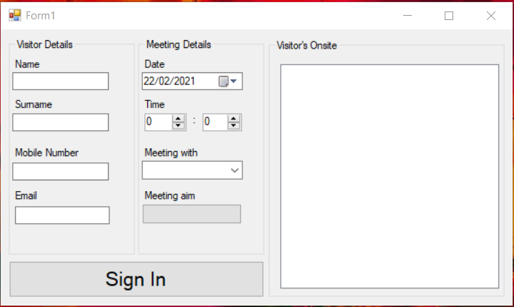

The application is made in a window form as shown.

2.2 Meeting Aim Button

Meeting aim button was added to avoid clutter and to much information on form 1, so when selected form 2 pops up.

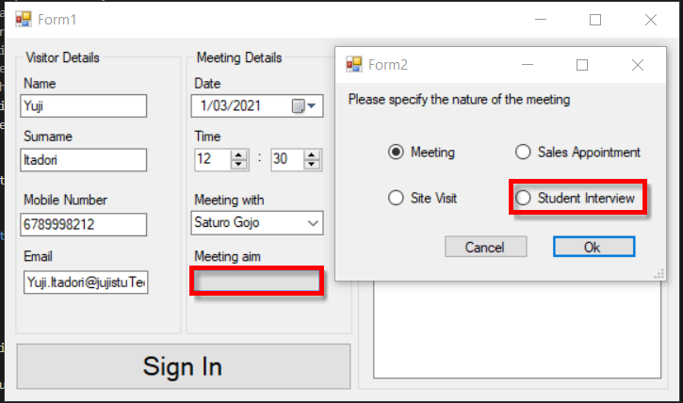

2.3 Form 2 Design

Made as a pop up when meeting aim is selected.

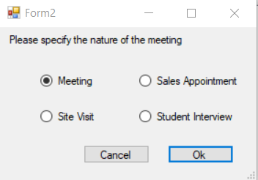

2.4 Info Stored example:

When the reception enters all needed information the information then moves to the visitor’s onsite section of the application and where all the details are stored and displayed.

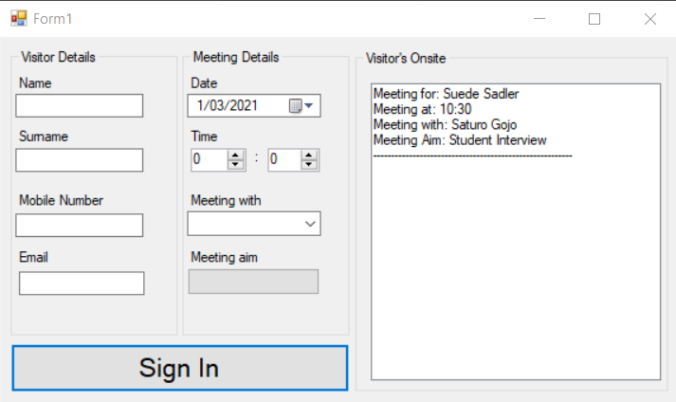

2.5 Radio Buttons:

Radio buttons were used in form 2 so they could not sign in with out selecting a meeting aim.

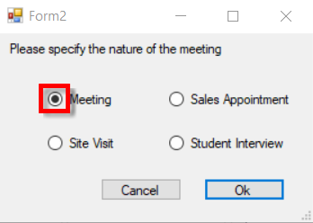

3. Feature and Functions

3.1 Visitor details:

Basic first and last name entry, with a number validation on entered mobile number and email validation on the entered email address.

3.2 Meeting details:

Date and time are stored and recorded.

Meeting with section is a drop-down box with a stored list of employees of the company who take the meetings.

The meeting aim is a pop-up form where you select a meeting aim from the form and then is shown in meeting aim section of form 1 which is the stored and recorded.

3.3 Sign In:

When all he information you have entered is correct and valid you are then able to sign in. then the information is displayed on the visitor’s onsite section.

3.4 Deletion of visitor information:

When the visitors finished with the meeting the receptionist can then clear the meeting in the visitor’s onsite section by clicking on the meeting information and pushing the delete function